FOR IMMEDIATE RELEASE
Contact: Jim Jones (641) 442-5105
By: Jim Jones
Date: August 25, 2023 (for upcoming issue, August 31st)

Who was W.A. Hopkins?
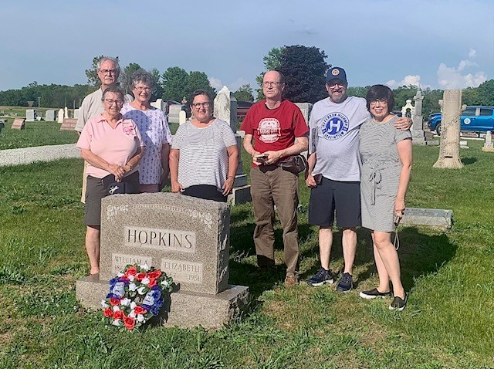
Organizers of the Jefferson Highway Association (JHA) caravan at a wreath laying ceremony for W.A. Hopkins in June. JHA president Roger Bell 2nd from right.
Jefferson Highway Association (JHA) president Roger Bell and organizers of JHA’s Sociability Caravan laid a wreath at the resting place of W.A. Hopkins last June. Townspeople were unaware of this tribute that was not on the event schedule, and most do not know the indelible mark he made on our community.
Hopkins was a man whose memory prompted a comprehensive 6600-word series in the Lamoni Chronicle by local historian T.A. Williams in 1963. Williams said, “His power of initiative, business ability, and energy have been factors of importance in the building of Lamoni.” Williams noted that Hopkins was “an ardent promoter of civic, social and cultural progress,” with contributions spanning across the Midwest.
William Alexander Hopkins was born in California 1867 to William and Elizabeth Horner Hopkins. When he was 5 his family moved to Lamoni. He grew up here and graduated from Lamoni High School with honors as a class leader and gifted orator. At 17 he became the town’s undertaker and opened a furniture store in partnership with his brother, both of which he fully owned by age 21.
In 1886, he married Elizabeth Clum and purchased a house at the site of the Family Dollar store today. Later, he erected a grand home on that lot, which became a central hub for social and business activities.
After 15 years as the undertaker and owner of the furniture business, he sold both to pursue other interests. The White name became linked to the funeral and furniture businesses for the ensuing fifty years. When Hopkins divested from these businesses in 1900, he had already engaged in real estate transactions, secured a position on the town council, assumed the role of town banker, managed a telephone company that he helped found, all of which granted him valuable insights into the area’s needs and opportunities.
As a young councilman, Hopkins championed streetlights in town, collaborating with town leaders and outside experts to propose the idea. The council deemed it too extreme, given that city lights had only emerged 14 years earlier in New York City. Hopkins also devised plans for water and fire protection, yet strong opinions and competing interests hindered progress. Despite this, his efforts foreshadowed future advancements.
Throughout his dedicated service, he played instrumental roles on Lamoni’s School Board, Park Board, Rose Hill Cemetery Board, Board of Trade, and the Commercial Club—an entity akin to the Chamber of Commerce. Amid World War I, he served as county chairman for the Red Cross. Spanning these diverse roles, he influenced where the college would be located, the formation of North Park, building the Coliseum, constructing the bank building at Main and Linden, paving city streets, and establishing a telephone company to bring in this new technology. As both president of a real estate firm and Lamoni’s foremost banker, he oversaw neighboring banks and traversed the Midwest, championing local commerce and social progress.
While Marietta Walker’s donation of 20 acres for Graceland College’s formation is widely recognized, this act was in conjunction with 13 1/3 acres contributed by Hopkins and 6 2/3 acres by Minnie Wicks. The RLDS church, now the Community of Christ (CofC), received this 40-acre donation, contingent upon establishing a college within five years—an astute strategy that Hopkins probably suggested to ensure the church’s dedication to the task. Further underscoring his commitment, Hopkins sold an additional 26 acres to the cause and served for several years on Graceland’s Board of Trustees.
Hopkins’ greatest accolades and reason for the wreath ceremony lies in his important role in the establishment of the Jefferson Highway. His enthusiasm for the “good roads” movement was ignited in 1911 when he joined the Waubonsie Trail Association, whose mission was to create a river-to-river trail. He championed a route, effectively advocating against rival claims from other towns, asserting that it should span the southern tier of Iowa counties—traversing Leon, Davis City, Lamoni, and Mt. Ayr. His visionary mind conceived yet another trail, connecting Des Moines to Kansas City and intersecting at Lamoni’s crossroads. To accomplish this he organized the Interstate Trail Association (ITA) for this second trail and under his persuasive leadership acquired land agreements and municipal cooperation along the route. By 1915, the ITA established a northern division, facilitating the trail’s marking from Des Moines to St. Paul, MN.
Meanwhile, 1915 saw the inception of the Jefferson Highway Association (JHA), whose organizers envisioned a paved roadway from New Orleans, LA, to Winnipeg, Canada. It was a monumental undertaking and since the ITA had already established a route that could become part of it, Hopkins was invited to JHA meetings. In 1917, Hopkins was enthusiastically voted in as JHA president and the ITA voluntarily disbanded to merge with JHA.
The Jefferson Highway became route 69 and the Waubonsie Trail route 2. Notably, route 2 got rerouted along a direct path between Leon and Mt. Ayr, bypassing Lamoni, upsetting Hopkins’ plan to position Lamoni at the crossroads. None the less, Lamoni was on the Jefferson Highway, a contributing factor to it being on I-35 today.
To celebrate the completion of the paving, Hopkins organized a border-to-border speed trip on the Jefferson Highway across Iowa to meet Minnesota’s governor at the state line for a dedication on October 30, 1930. W.A. Hopkins was the distinguished passenger with J.C. Danielson joining him and a young Ralph Derry as the driver of a Chrysler sedan reminiscent of a gangster movie’s getaway car—a fitting association given that the Jefferson Highway served as an escape route for some notorious gangsters.
They travelled 70-75 mph in some stretches and 50 though towns, speeds made possible since it was well-publicized with cheering people along the route and local police escorts clearing the way through cities. They had one stop for gas, one stop for a freight train, and one stop to get directions around a construction site. Remarkably, they covered the 244-mile distance in a mere 231 minutes, achieving their ambitious mile-a-minute goal and even outpacing the governor with time for lunch while waiting. Through this feat, Hopkins showcased the feasibility of higher speeds that would be a boon for transportation of goods and services.
Through his unwavering commitment and visionary leadership, W.A. Hopkins left an indelible mark on Lamoni, shaping education, infrastructure, and commerce. The wreath that was laid at his Rose Hill resting place honored him for his influence that transcended our town.
#